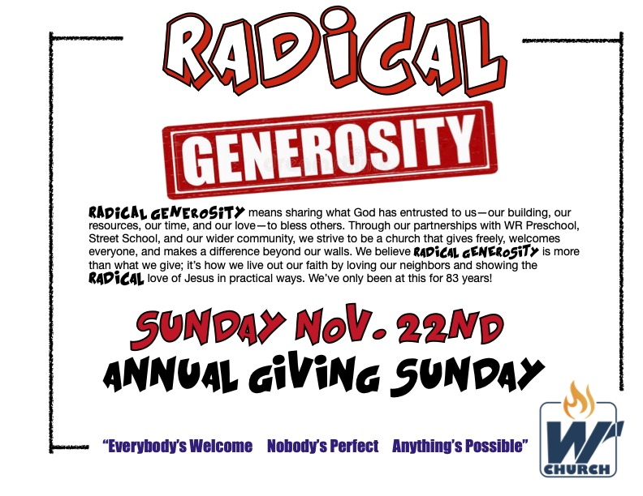
# 2 - RADICAL GENEROSITY
“The world of the generous gets larger and larger; the world of the stingy gets smaller and smaller.” Proverbs 11:24

2 CORINTHIANS 8-9

RADICAL GENEROSITY IS AN ______________ NOT AN ____________
“If you are really eager to give, then it isn’t important how much you have to give. God
wants you to give what you have, not what you haven’t.” 2 Corinthians 8:12 (TLB)

A MODEL OF 4 ATTITUDES

• RADICAL GENEROSITY IS _____________________
“Our friends, we want you to know what God’s grace has accomplished in the
churches in Macedonia. They have been severely tested by the troubles they went
through; but their joy was so great that they were extremely generous in their
giving, even though they are very poor.” 2 Corinthians 8:1-2

• RADICAL GENEROSITY IS ______________________

“For I testify that they gave as much as they were able, and even beyond their ability.” 2 Corinthians 8:3

• RADICAL GENEROSITY IS ___________________________
“Of their own free will they begged us and pleaded for the privilege of having a part
in helping God’s people in Judea.” 2 Corinthians 8:3-4

“Don’t give reluctantly or in response to pressure. ‘For God loves a person who
gives cheerfully.’” 2 Corinthians 9:7

• RADICAL GENEROSITY IS ___ _________________ _____________
“They gave in a way we did not expect: They first gave themselves to the Lord and
to us. This is what God wants.” 2 Corinthians 8:5

“The offering [is] a service that glorifies the Lord and shows our eagerness to help.”
2 Corinthians 8:19

THE RESULTS OF RADICAL GENEROSITY

1. IT ___________________ MY _________ FOR ______________
“But since you excel in everything—in faith, in speech, in knowledge, in complete
earnestness and in the love we have kindled in you—see that you also excel in
this grace of giving. I am not commanding you, but I want to test the sincerity of
your love by comparing it with the earnestness of others.”
2 Corinthians 8:7-8

“Your heart will be where your treasure is.” Matthew 6:21

2. IT MAKES _____ MORE LIKE __________________

“You are familiar with the generosity of our Master, Jesus Christ. Rich as he was,
he gave it all away for us—in one stroke he became poor and we became rich.”
2 Corinthians 8:9

3. IT ________________ MY ______________

“Remember this: Whoever sows sparingly will also reap sparingly, and whoever
sows generously will also reap generously. . . . for God loves a cheerful giver. And
God is able to bless you abundantly, so that in all things at all times, having all that
you need, you will abound in every good work.” 2 Corinthians 9:7-8

"God gives seed to the farmer and food to those who need to eat. God will also
give you seed and multiply it. In your lives he will increase the things you do that
have his approval. God will make you rich enough so that you can always be
generous.” 2 Corinthians 9:10-11

4. IT CAUSES _____________ TO _____________ _______

“Your generosity will result in thanksgiving to God.” 2 Corinthians 9:11
“For this service you perform not only meets the needs of God’s people, but also produces an outpouring of gratitude to God.” 2 Corinthians 9:12

5. IT ____________ ________ WITH A ____________ TO THE WORLD
“You will honor God through this genuine act of service because of your
commitment to spread the Good News of Christ and because of your generosity.”
- Corinthians 9:13

