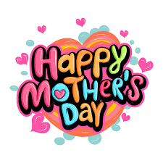
"It's not easy being a mom. If it were easy, fathers would do it." Betty White
"My mother's menu consisted of two choices: Take it or leave it." Buddy Hackett
"Silence is golden. Unless you have kids. Then silence is just suspicious." Unknown
“The quickest way for a parent to get a child’s attention is to sit down and look comfortable.” Lane Olinghouse
“ TOGETHER WOVEN “
1.BELONGING IS GOD’S ________ TO US “That’s plain enough, isn’t it? You’re no longer wandering exiles. This kingdom of faith is now your home country. You’re no longer strangers or outsiders. You belong here, with as much right to the name Christian as anyone. Ephesians 2:19
2.GOD IS IN ______________ EVEN IF IT SEEMS LIKE THE WORLD IS OUT OF _______________
“Where can I go from your Spirit? Where can I flee from your
presence?” Psalm 139:7

3.GOD SKILLFULLY _____________US TOGETHER INTO A BEAUTIFUL __________________
“Now abide faith, hope and love, but the greatest of these is love.” 1 Corinthians 13:

