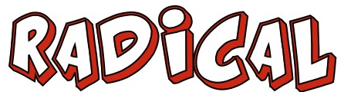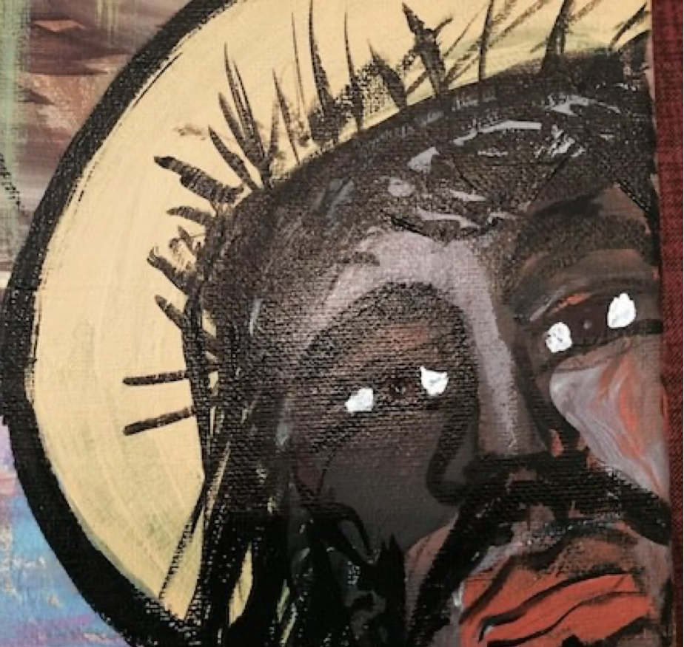
#1 – RADICAL FAITH

“Without faith it is impossible to please God, because anyone who comes to Him must believe He exists and that He rewards those who earnestly seek Him.” Hebrews 11:6

RADICAL FAITH IS…

1.______________ WHEN I DON’T ______ IT
“Faith is being sure of what we hope for and certain of what we do not see.”
Hebrews 11:1

2.______________ WHEN I DON’T ________________ IT
“It was by faith that Noah built an ark to save his family from the flood. He obeyed God, who warned him about something that had never happened before.” Hebrews 11:7

“It was faith that made Abraham obey when God called him and go out to a country God had promised to him. He left his own country without knowing where he was going.” Hebrews 11:8

3.______________ WHEN I DON’T _________ _________ IT
“It was by faith that Moses left Egypt and was not afraid of the king's anger. He held to his purpose like a man who could see the invisible.” Hebrews 11:27

“What is faith? It is the confident assurance that what we hope for is going to happen. It is the evidence of things we cannot yet see.” Hebrews 11:1

4._______________ IT IN _________ TO ________________ IT

“It was by faith that Joseph, when he was about to die, confidently spoke of God's bringing the people of Israel out of Egypt. He was so sure of it that he commanded them to carry his bones with them when they left!” Hebrews 11:22

“By faith, we see the world called into existence by God's word, what we see created by what we don't see.” Hebrews 11:3

“For he spoke, and it came to be.” Psalm 33:9

(God said) "I have made you a father of many nations... God who gives life to the dead and calls things that are not as though they were.” Roman 4:11

“God speaks of future events with as much certainty as though they were already past.”
Romans 4:17

“For it is by our faith that we are put right with God; it is by our confession that we are
saved.” Romans 10:10

5._____________ WHEN I ________ HAVE ____
“It was faith that made Abel's offering to God a better sacrifice than Cain's. Through his
faith…God approved of his giving.” Hebrews 11:4

“Because of their great joy… They gave even more than they could afford.”2 Cor. 8:2-3

“Honor the Lord by giving him the first part of all your income, and he will fill your barns
and overflow your barrels with the finest wines.” Proverbs 3:9

“On every Lord's Day each of you should put aside something from what you have earned during the week, and use it for your offering. The amount depends on how much the Lord has helped you earn.” 1 Corinthians 16:2

6.______________ GOD BEFORE I _____________ IT
“By faith the walls of Jericho fell, after the people had marched around them for seven
days.” Hebrews 11:30

“When you pray and ask for something, believe that you have received it, and you will be given what you ask for.” Mark 11:24

“Jesus said, ‘Because of your faith, it will happen.’” Matthew 9:29

7.________________GOD IF I ________ GET IT

“They were all commended for their faith, yet none of them received what had been
promised. God had planned something better...” Hebrews 11:39-40

“Faith comes from hearing the Word of God…” Romans 10:17

Download the YouVersion Bible App – download the Bible Study BECOME RADICAL LIKE JESUS

